The Overall Limit

* about values of x that are close to a, period, without restricting to one side or the other

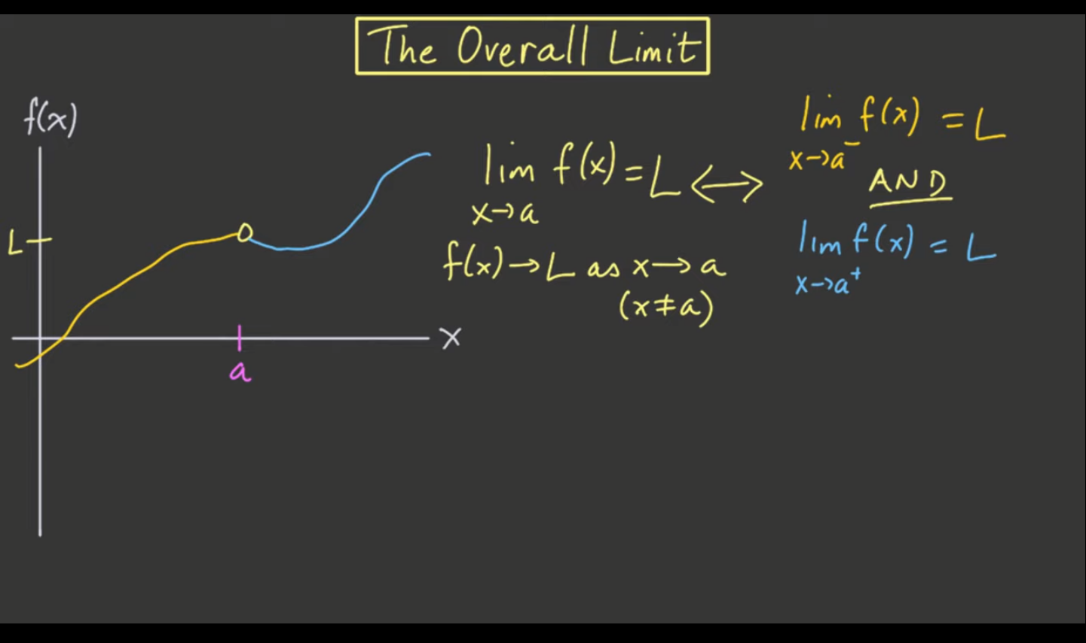

* remember: functions do not affect the limit!
  + Limits only care about values of x that are close to a, but not equal to a.
  + So, for the sake of the overall limit, it's not going to matter whether we have a dot for f of a

These limits have NO OVERALL LIMIT

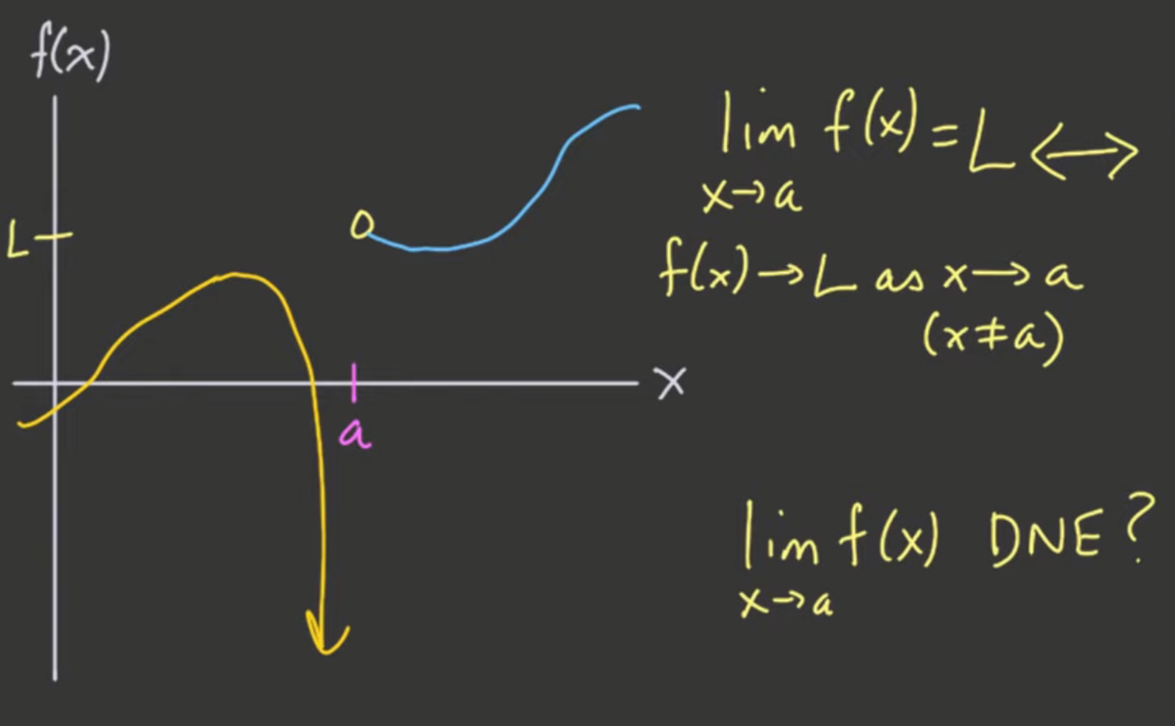

* One side asymptotic (or any one side DNE)

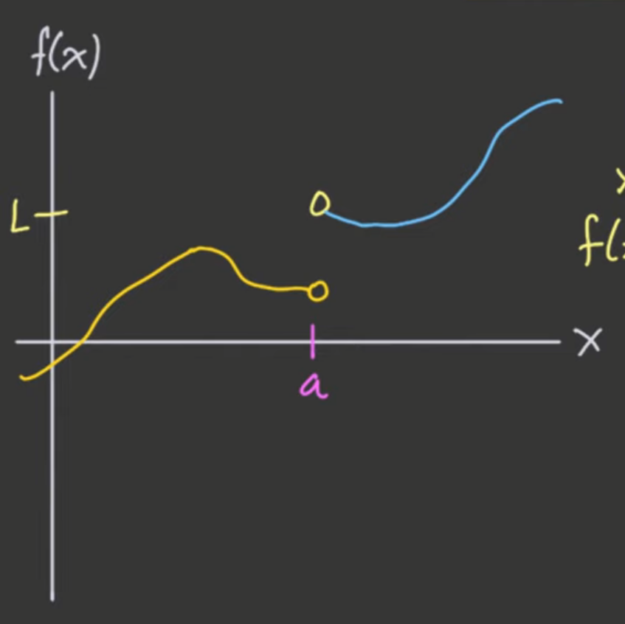

* Not equal LIMITS

NOTE: both limits must be EQUAL to have OVERALL LIMIT!

* In simple words, the LIMIT
* We will not be considering left and right separately anymore
* Functions will only have limits if the left-hand and right-hand limit EQUAL to each other

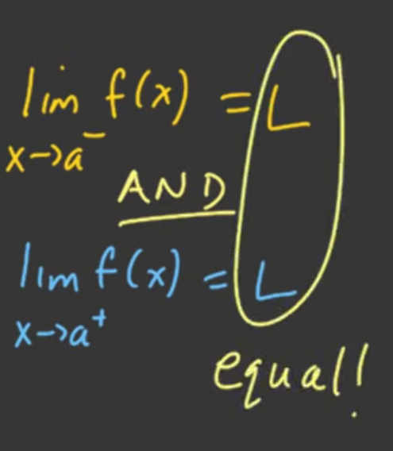

Limit definition:

The Limit in Words

* If a function f(x) approaches some value L as x approaches a from **both** the right and the left, then the limit of f(x) exists and equals L.

The Limit in Symbols

If

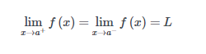

then

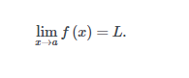

Alternatively,



**Remember that x is approaching a but does not equal a.**

Formal definition





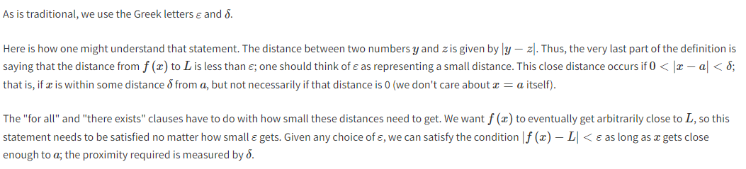

Limits from graphs

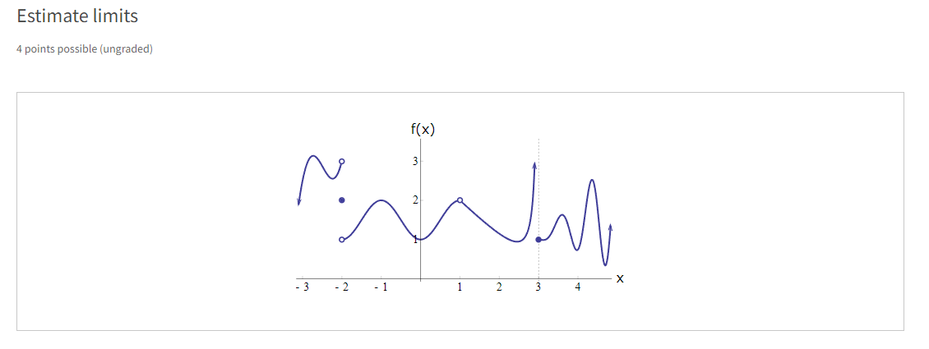

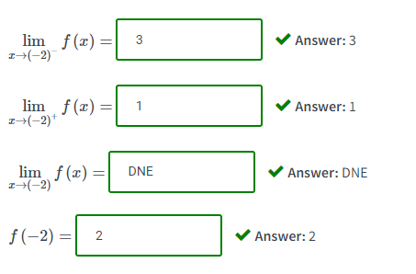



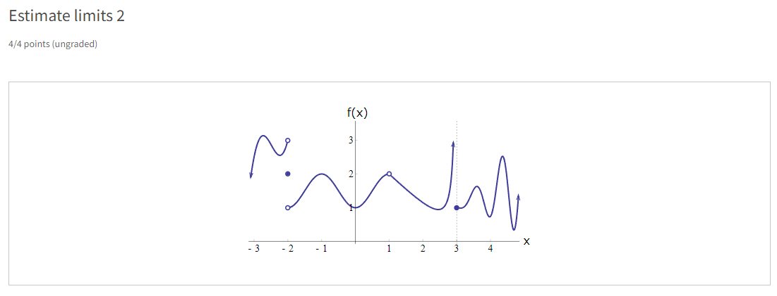

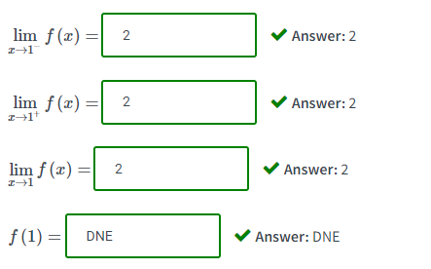

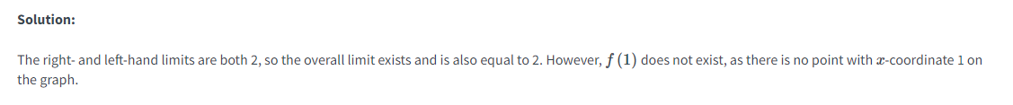

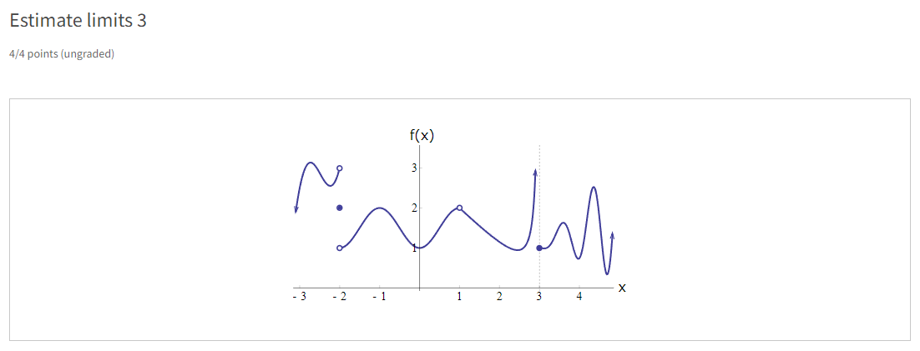

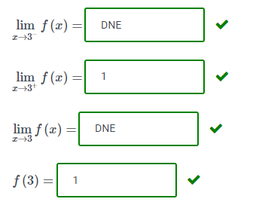



Review Problems

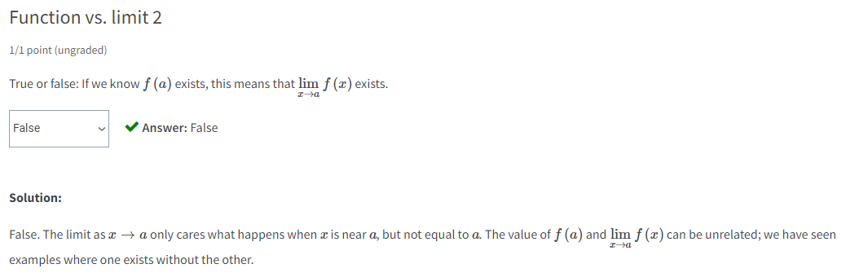

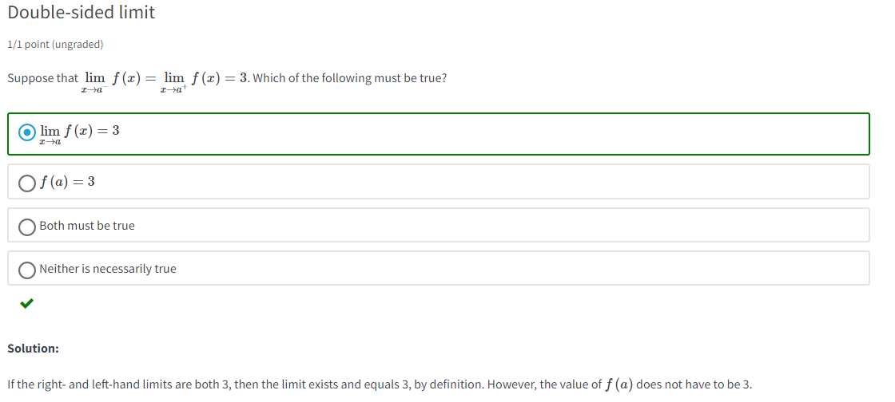

floor function ⌊x⌋

* denotes the greatest integer **less** than or **equal** to x.

